Diseño Esquemático

Decoder BCD

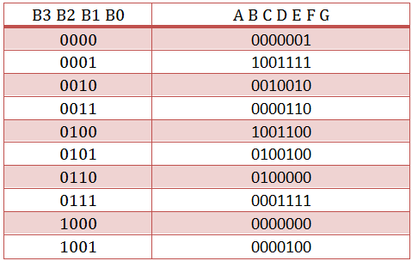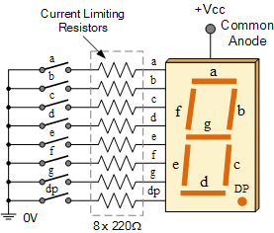

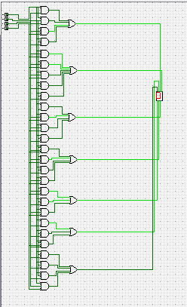

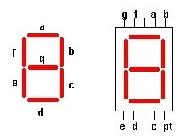Expresión Booleana

A = B0 + B2 + B1B3 + B1’B3′

B = B1′ + B2’B3′ + B2B3

C = B1 + B2′ + B3

D = B1’B3′ + B2B3′ + B1B2’B3 + B1’B2 + B0

E = B1’B3′ + B2B3′

F = B0 + B2’B3′ + B1B2′ + B1B3′

G = B0 + B1B2′ + B1’B2 + b2b3′

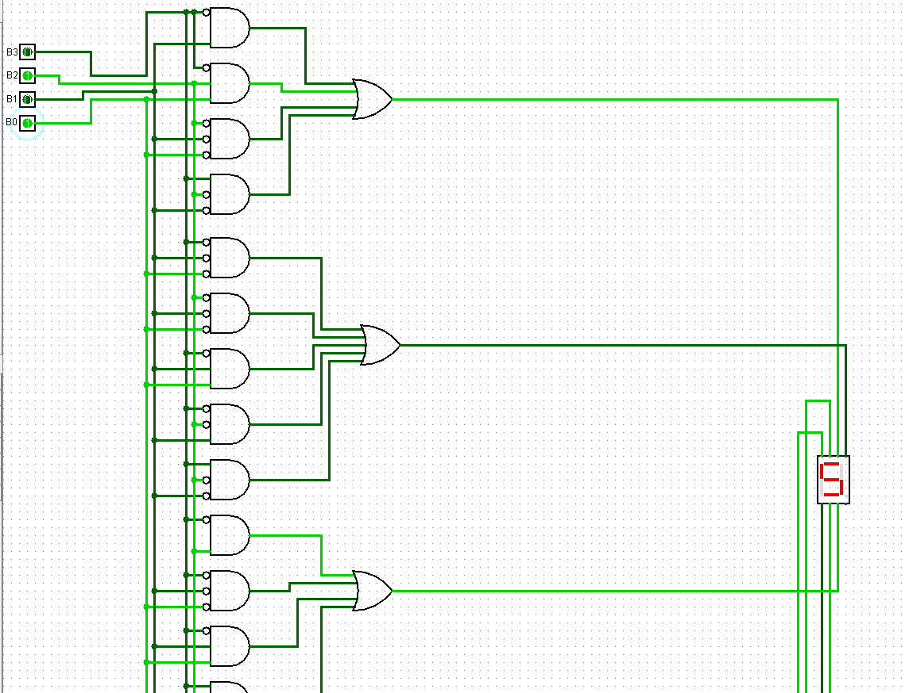

Controlador

|  |  |  |  |  |  |  |  |  |  |  |  |  |  |  |  |  |  |  |
| --- | --- | --- | --- | --- | --- | --- | --- | --- | --- | --- | --- | --- | --- | --- | --- | --- | --- | --- |
|  | Q3 | Q2 | Q1 | Q0 |  | Q3 | Q2 | Q1 | Q0 |  | J3 | K3 | J2 | K2 | J1 | K1 | J0 | K0 |
| 0 | 0 | 0 | 0 | 0 |  | 1 | 1 | 1 | 0 |  | 1 | X | 1 | X | 1 | X | 0 | X |
| 7 | 0 | 1 | 1 | 1 |  | 1 | 1 | 1 | 0 |  | 1 | X | X | 0 | X | 0 | X | 1 |
| 8 | 1 | 0 | 0 | 0 |  | X | X | X | X |  | X | X | X | X | X | X | X | X |
| 9 | 1 | 0 | 0 | 1 |  | X | X | X | X |  | X | X | X | X | X | X | X | X |
| 10 | 1 | 0 | 1 | 0 |  | X | X | X | X |  | X | X | X | X | X | X | X | X |
| 11 | 1 | 0 | 1 | 1 |  | 0 | 1 | 1 | 1 |  | X | 1 | 1 | X | X | 0 | X | 0 |
| 12 | 1 | 1 | 0 | 0 |  | X | X | X | X |  | X | X | X | X | X | X | X | X |
| 13 | 1 | 1 | 0 | 1 |  | 1 | 0 | 1 | 1 |  | X | 0 | X | 1 | 1 | X | X | 0 |
| 14 | 1 | 1 | 1 | 0 |  | 1 | 1 | 0 | 1 |  | X | 0 | X | 0 | X | 1 | 1 | X |
| 15 | 1 | 1 | 1 | 1 |  | X | X | X | X |  | X | X | X | X | X | X | X | X |

**J3= 1**

**K3= Q2N**

**J2= 1**

**K2= Q1N**

**J1=1**

**K1=Q0N**

**J0=Q1**

**K0=Q3N**

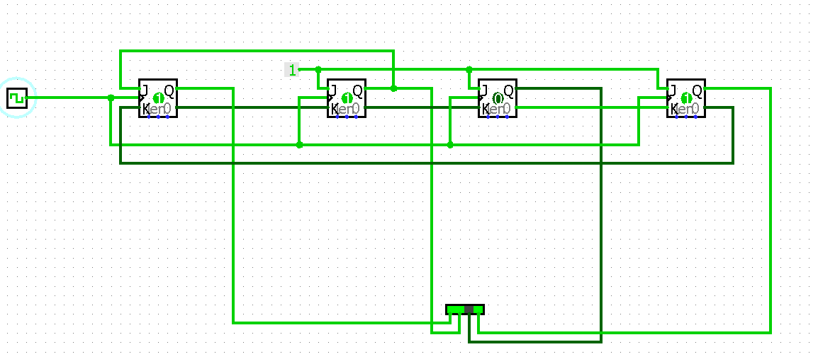

**Mux Para pasar digitos**

|  |  |  |  |  |  |  |  |
| --- | --- | --- | --- | --- | --- | --- | --- |
|  | Q3 | Q2 | Q1 | Q0 |  | A | B |
| 7 | 0 | 1 | 1 | 1 |  | 1 | 1 |
| 11 | 1 | 0 | 1 | 1 |  | 1 | 0 |
| 13 | 1 | 1 | 0 | 1 |  | 0 | 1 |
| 14 | 1 | 1 | 1 | 0 |  | 0 | 0 |

**A=**Q3N OR Q2N

B=Q3N OR Q1N

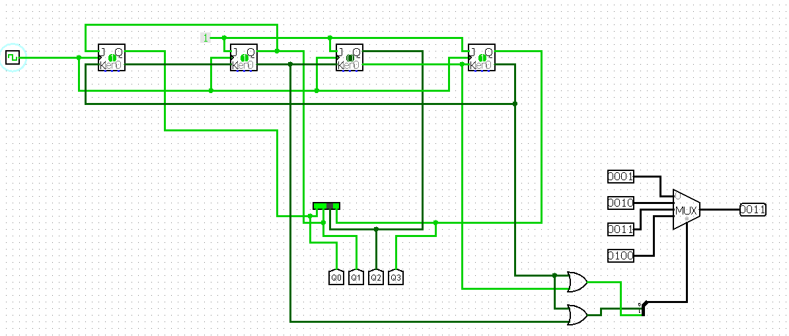

**Diseño Final**